MINI PROJECT

**Exploratory Data Analysis (EDA)**

A project report on exploring the dataset

on

**Car sales**

*Submitted by*

***NIVETHA SREE M***

*Computer Science and Engineeering*

*Adhiyamaan College Of Engineering, Hosur.*

Date: 12/12/2022

Objective:

To Explore the dataset (EDA) .

Dataset: Car Sales.

Link for dataset: <https://www.kaggle.com/datasets/gagandeep16/car-sales>

REPORT: 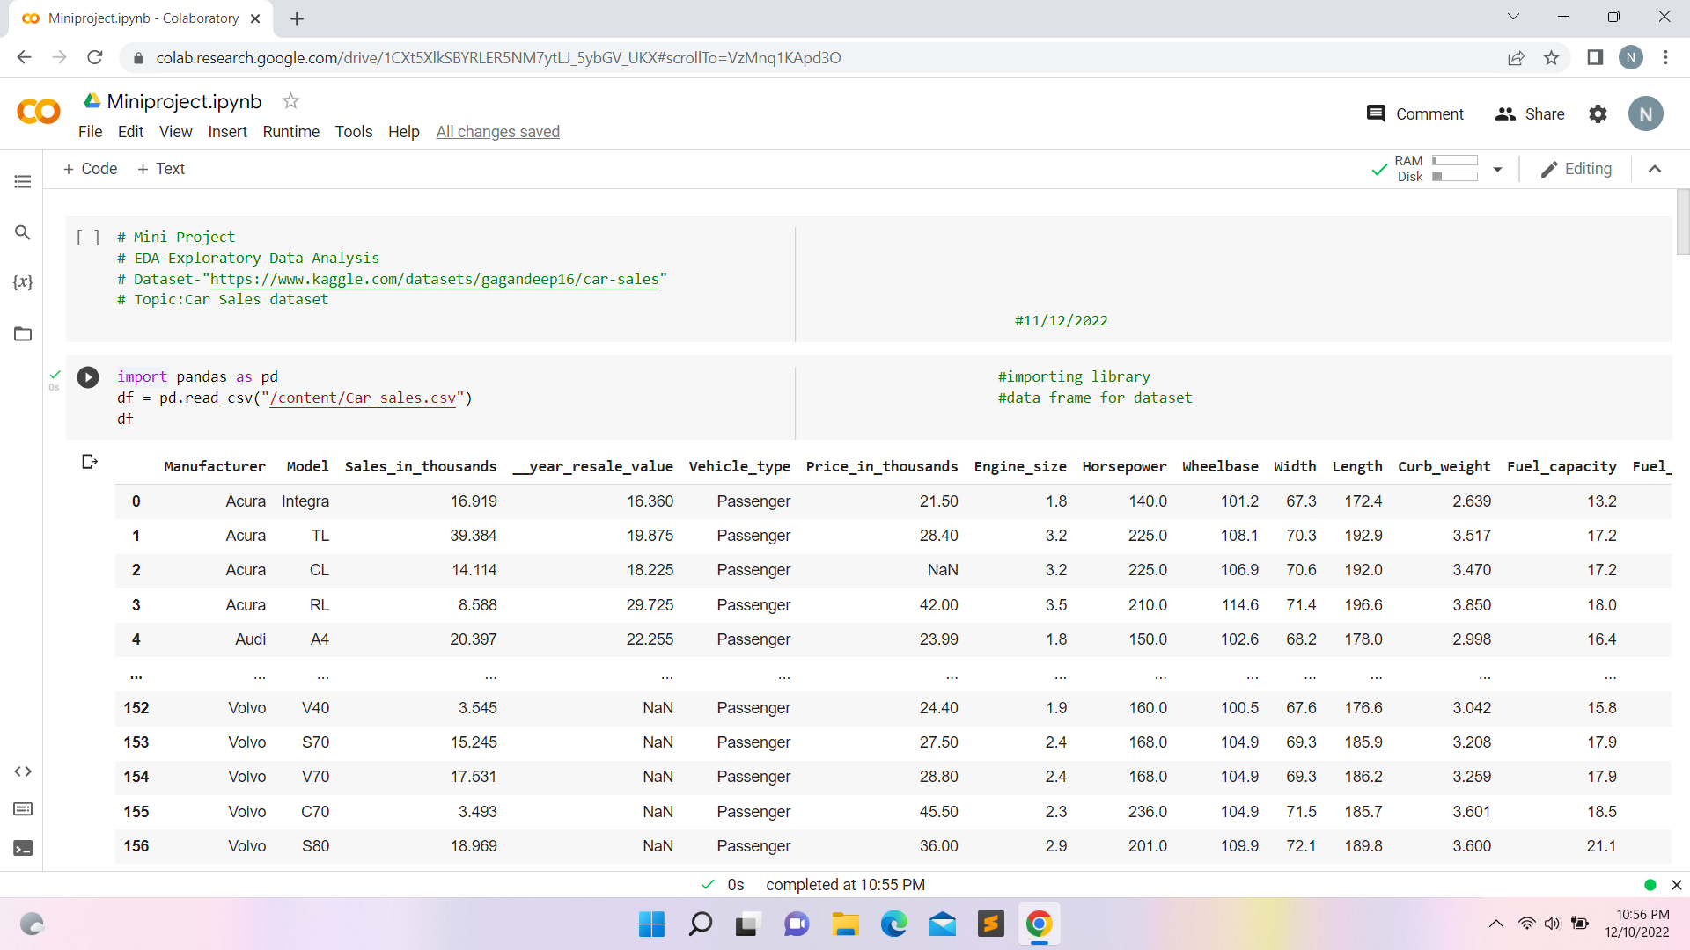

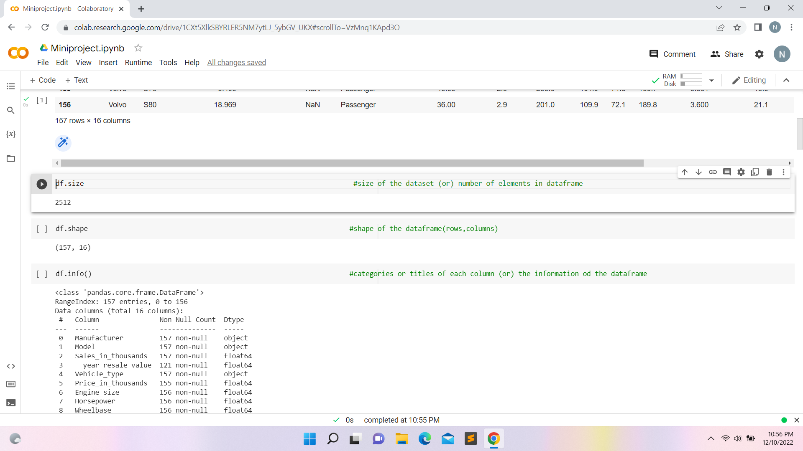

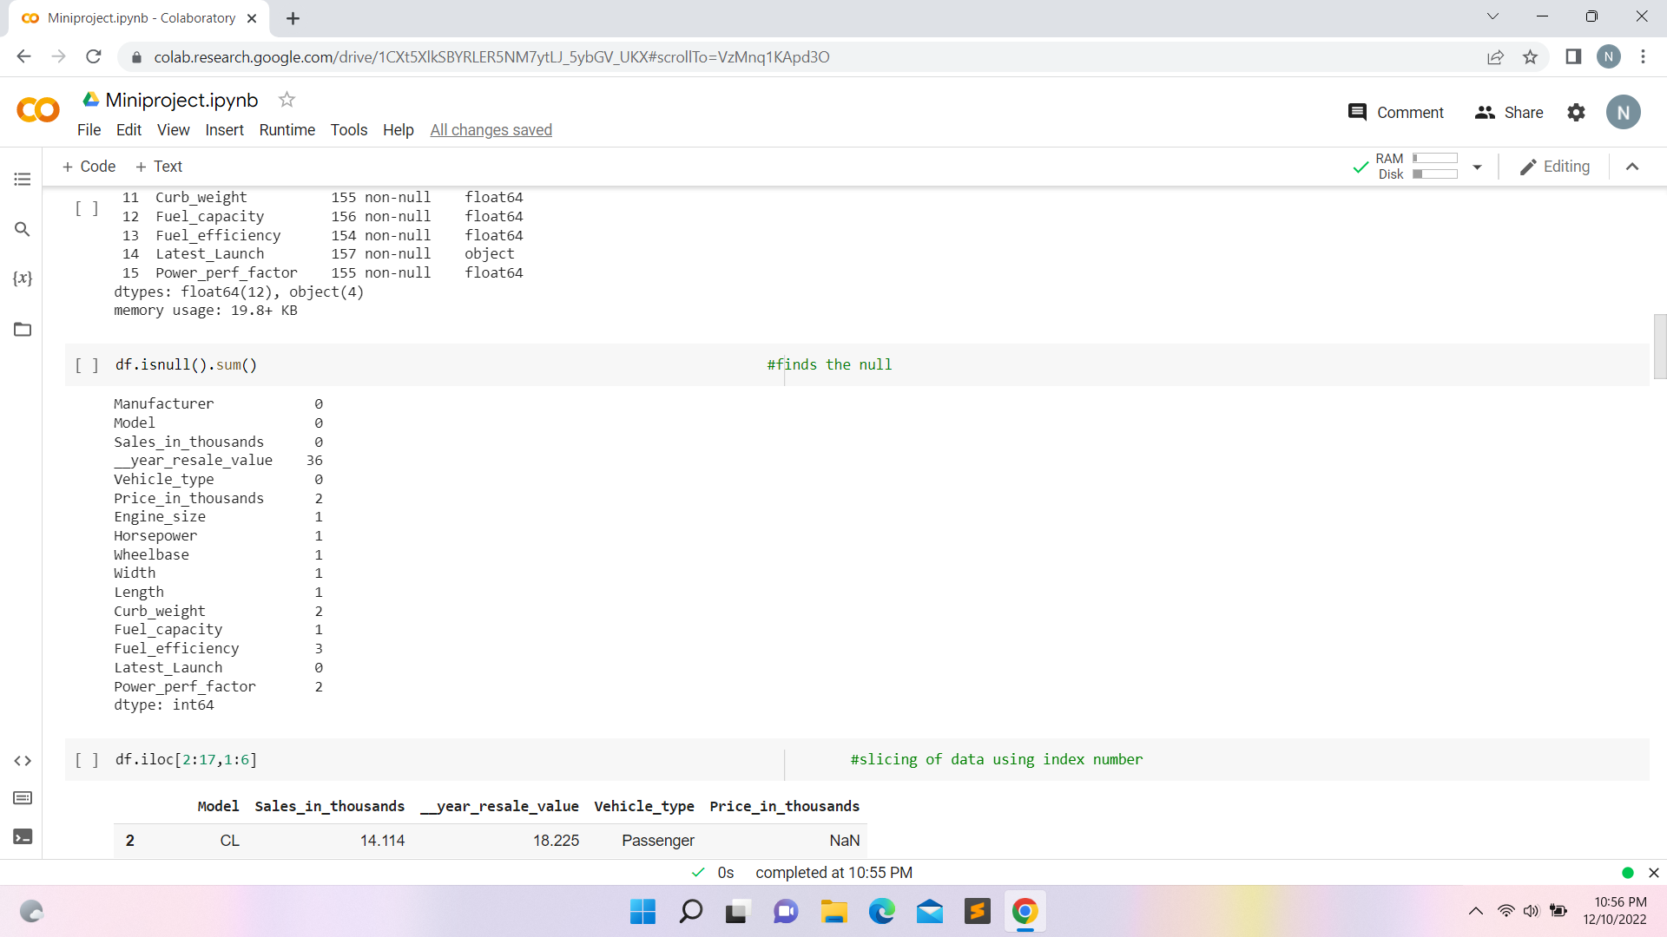

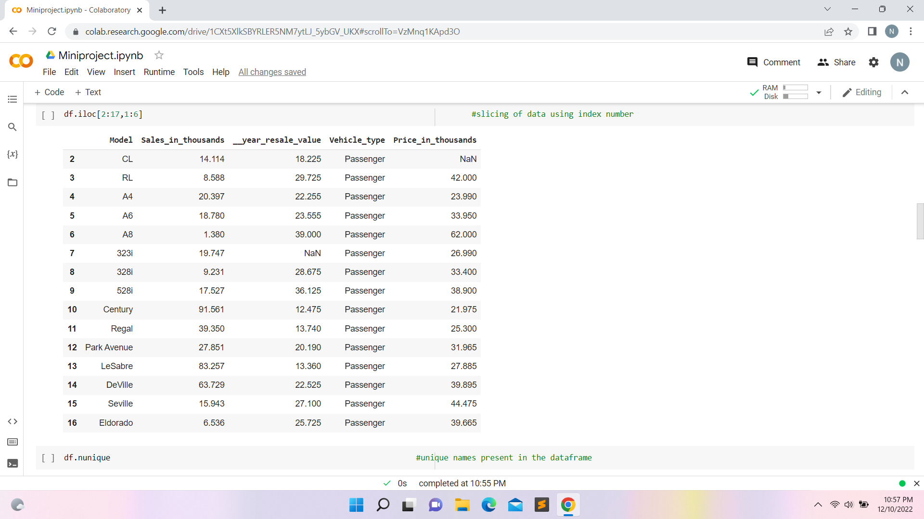

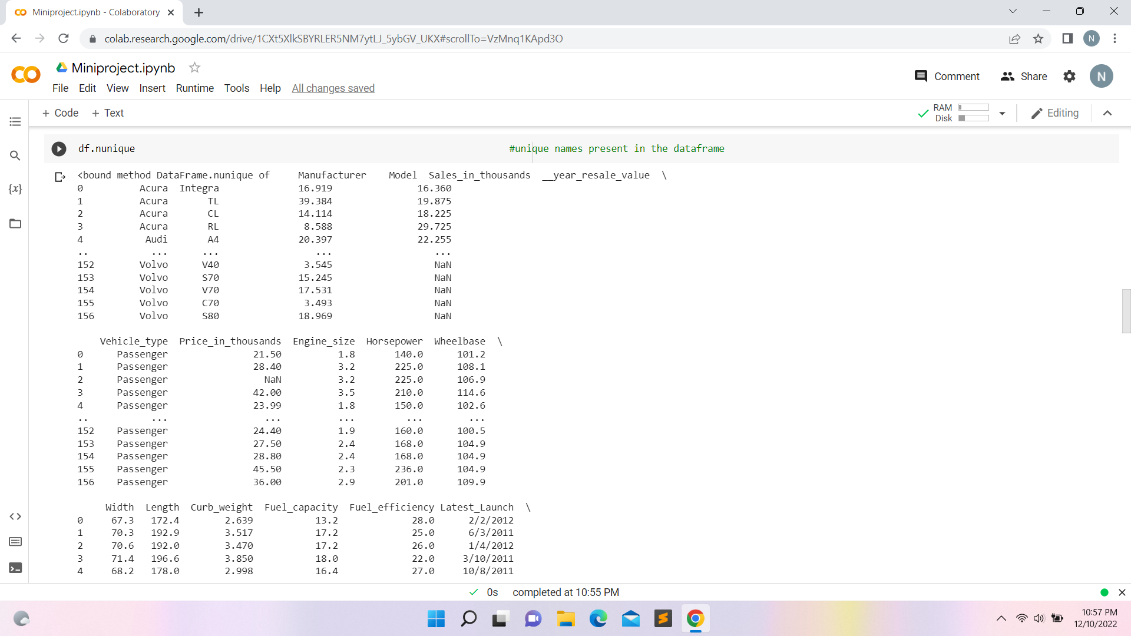

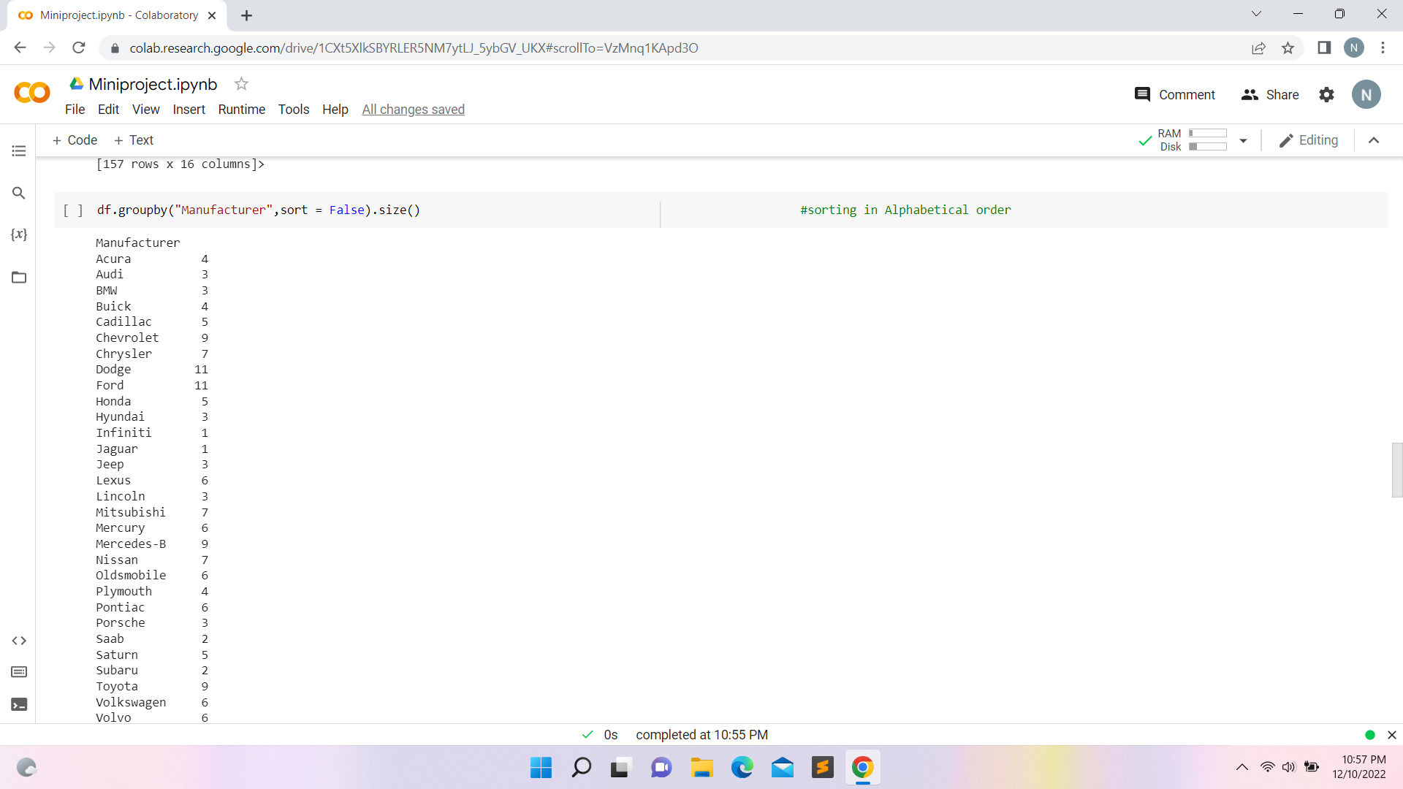

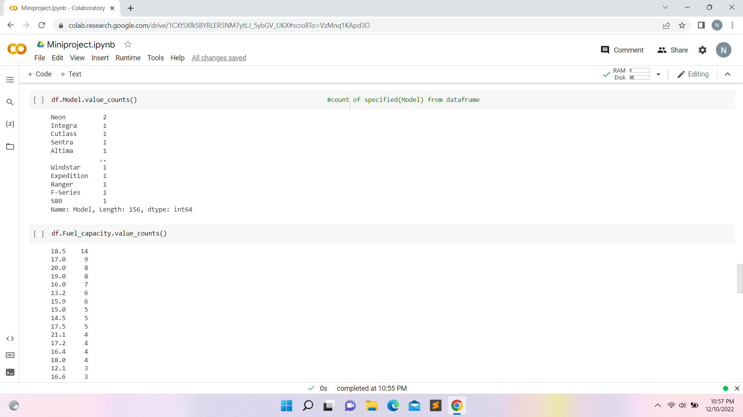

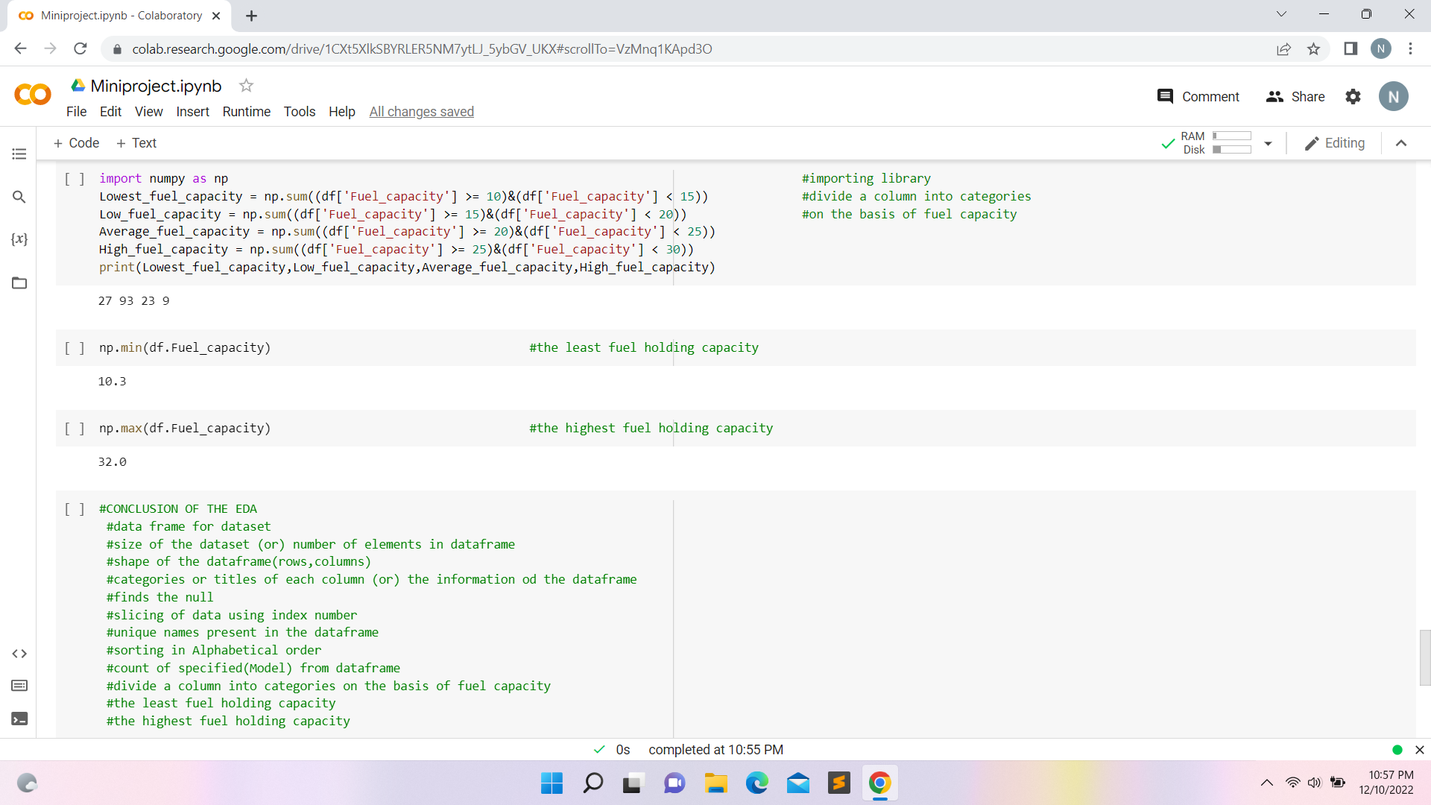

LINK TO DRIVE: <https://tinyurl.com/rinexprojnivetha>